Docket 2025-1 Subject 1: Full-Scale Density Classifications
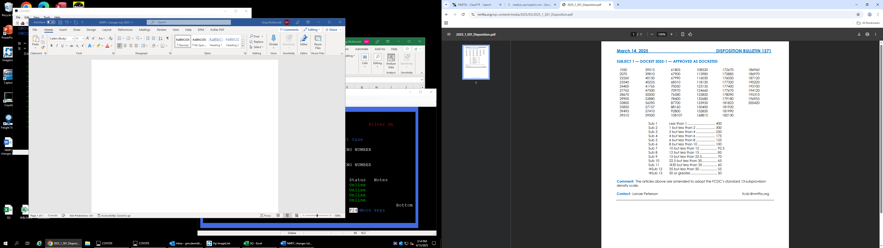

Docket 2025-1 Subject 2: Modified Density Scale Items

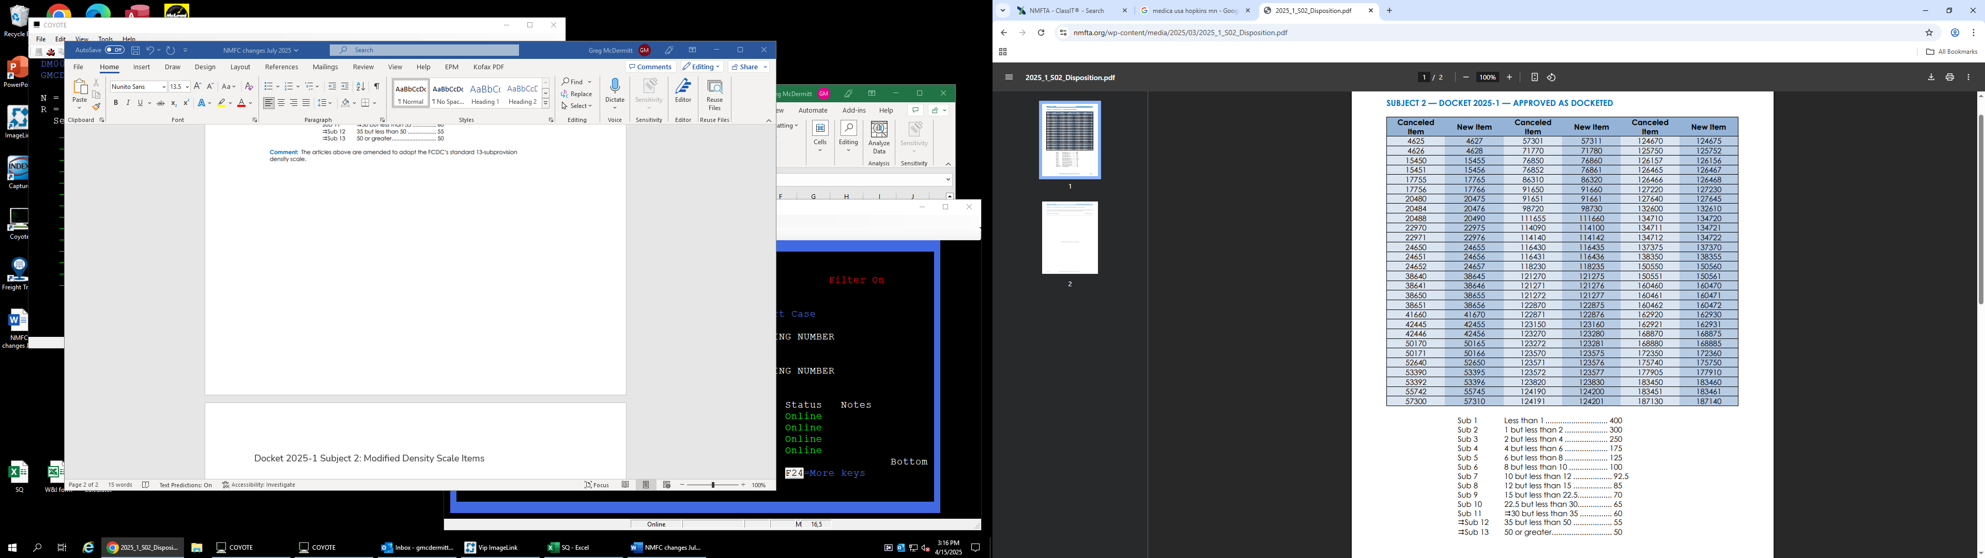
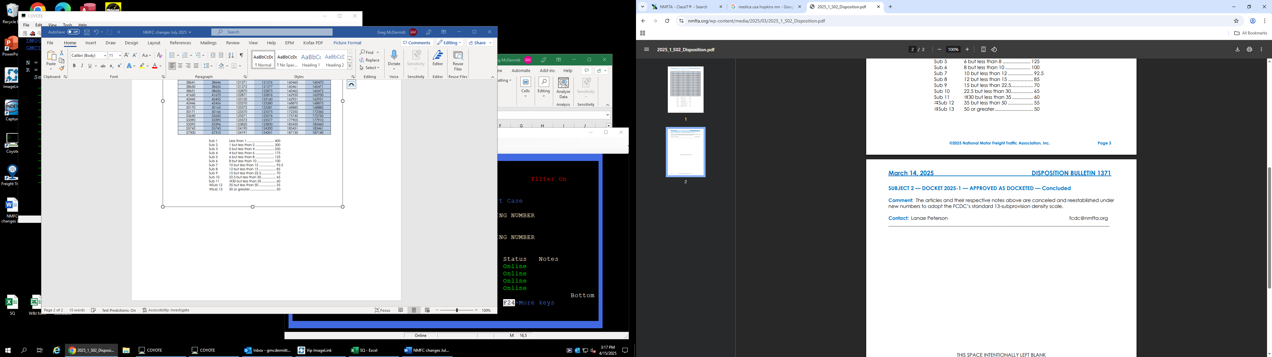

Docket 2025-1 Subject 3: Handling, Stowability, and Liability Considerations

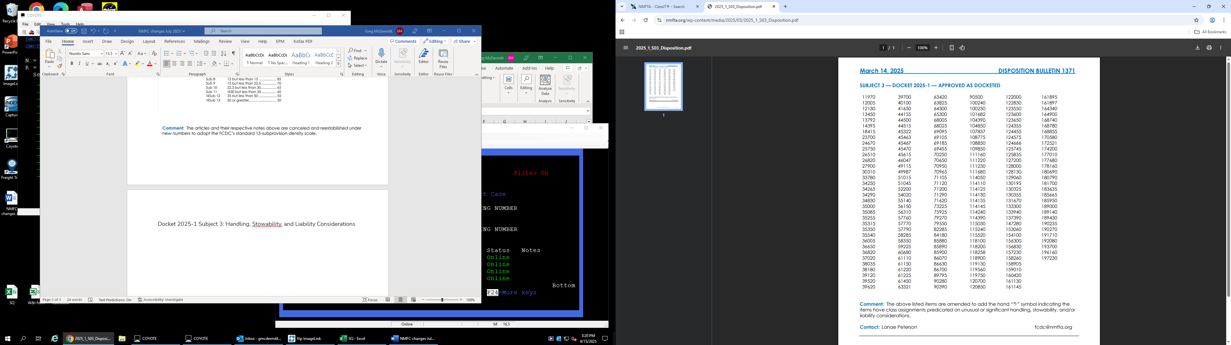

Docket 2025-1 Subject 4: Alloys
Multiple items applying on alloys are amended, canceled, or established, as shown. New item 12710.
Docket 2025-1 Subject 5: Aluminum
Multiple items applying on aluminum articles are amended, canceled, or established, as shown. As modified, multiple packaging provisions are amended. NMFC 13120

Docket 2025-1 Subject 6: Ammunition, Not Explosive, Group
Multiple items applying on nonexplosive ammunition are canceled with reference to a new item, as shown. New item 14010

Docket 2025-1 Subject 7: Artists’ or Crafters’ Materials or Supplies Group
Multiple items applying on artists’ or crafters’ materials or supplies are amended, canceled, or established, as shown. NMFC 14535

Docket 2025-1 Subject 8: Athletic Goods Group
Multiple items applying on athletic or sporting goods are amended, canceled, or established, as shown. NMFC 15520

Docket 2025-1 Subject 9: Automobile Parts Group
Multiple items applying on automobile parts are amended, canceled, or established, as shown. NMFC 18260

Docket 2025-1 Subject 10: Bags
Multiple items applying on bags are amended, canceled, or established, as shown. NMFC 20580

Docket 2025-1 Subject 11: Barks
Multiple items applying on barks are canceled with reference to a new item, as shown. New item 21510

Docket 2025-1 Subject 12: Bee Group
Multiple items applying on bee supplies are canceled with reference to a new item, as shown New item 23150
Docket 2025-1 Subject 13: Blacks, Dry
Not Approved

Docket 2025-1 Subject 14: Boilers, Furnaces, Stoves and Related Articles Group
Multiple items applying on boilers, furnaces, stoves, and related articles are amended, canceled, or established, as shown. New item 25525
As modified, item 26720 remains separate and adopts full-scale, density-based provisions. Note, item 26721 remains unchanged. The description of item 25525 is amended to read “Parts thereof,” replacing “Parts named,” and

Docket 2025-1 Subject 15: Booths
Not Approved

Docket 2025-1 Subject 16: Boot Group
Multiple items applying on boots or shoes are canceled with reference to a new item, and several Notes are established, as shown. New item 28130

Docket 2025-1 Subject 17: Box Group
Multiple items applying on boxes or crates are amended, canceled, or established, as shown. As modified, packaging requirements for “Boxes, wood, NOI; with or without components of other materials,” and “Boxes or Cartons, fiberboard or paperboard, NOI; with or without components of other materials” are removed. NMFC 29785

Docket 2025-1 Subject 18: Brass, Bronze or Copper
Multiple items applying on brass, bronze, or copper articles are amended, canceled, or established, as shown. NMFC 30160

Docket 2025-1 Subject 19: Brick Group
Multiple items applying on bricks and related articles are canceled with reference to a new item, and several Notes are established, as shown. New item 32275

Docket 2025-1 Subject 20: Building Materials, Miscellaneous Group
Multiple items applying on building materials are canceled with reference to a new item, and several Notes are established, as shown. New item 33785

Docket 2025-1 Subject 21: Building Woodwork Group
Note, item 37671 is canceled with no further application. As modified, item 37670 is canceled with reference to item 33785 (see Subject 20).

Docket 2025-1 Subject 22: Camera Group
Multiple items applying on cinema, photographic or video recording equipment or materials are canceled with reference to a new item, and several Notes are established, as shown. As modified, the following entries are removed from the “viz.”: “Screens, motion picture, NOI,” “Screens, projection, portable, roller-type, other than motor operated, with or without stands,” and “Screens, television projection.” New item 39625

Docket 2025-1 Subject 23: Carbon
Multiple items applying on carbon are canceled with reference to a new item, and one Note is established, as shown. As modified, the provisions of items 40590, 40600, 40650, 40660 will continue to apply with no changes. New item 40570

Docket 2025-1 Subject 24: Carriers, Shipping, Group
Multiple items applying on shipping carriers are canceled with reference to a new item, and several Notes are established, as shown. New item 40775

Docket 2025-1 Subject 25: Cement Group
Multiple items applying on cement, lime, or plaster are canceled with reference to a new item, and one Note is established, as shown. New item 42110
Docket 2025-1 Subject 26: Chemicals Group
Multiple items applying on chemicals are canceled with reference to a new item, and several Notes are established, as shown. New item 43955

Docket 2025-1 Subject 27: Clay Group
Multiple items applying on clays, concentrates, earths, or ores are canceled with reference to a new item, and one Note is established, as shown. New item 48135

Docket 2025-1 Subject 28: Cloth, Fabric, Dry Goods or Textile Group
Multiple items applying on cloth, fabric, dry goods, or textiles are amended, canceled, or established, as shown. NMFC 49260

Docket 2025-1 Subject 29: Clothing Group
Multiple items applying on clothing are amended, canceled, or established, as shown. NMFC 49880

Docket 2025-1 Subject 30: Conduits, Other Than Earthen, Group
Multiple items applying on conduits, other than earthen, are canceled with reference to a new item, and one Note is established, as shown. New item 50970

Docket 2025-1 Subject 31: Coolers Group
Multiple items applying on coolers, cooling boxes, cooling rooms or refrigerators, are canceled with reference to a new item, and several Notes are established, as shown. As modified, Notes, items 35087, 35814, and 123652 are amended to incorporate the new item number. New item 53125

Docket 2025-1 Subject 32: Cork
Multiple items applying on cork are canceled with reference to a new item, as shown. New item 53510

Docket 2025-1 Subject 33: Covers
Multiple items applying on covers are canceled with reference to a new item, and one Note is established, as shown. New item 54645

Docket 2025-1 Subject 34: Decorations Group
Multiple items applying on decorations are amended, canceled, or established, as shown. As modified, the minimum packaging requirements for specific listings are added. Additionally, the description format is modified for driftwood roots. NMFC 56040

Docket 2025-1 Subject 35: Dental, Hospital, Medical or Surgical Supply Group
Multiple items applying on dental, hospital, medical or surgical apparatus, instruments, machines, or supplies are amended, canceled, or established, as shown. NMFC 56590
As modified, the provisions of item 56545 will continue to apply with no change.

Docket 2025-1 Subject 36: Drawing Instruments, Optical Goods or Scientific Instruments
Multiple items applying on drawing instruments, optical goods, or scientific instruments are amended, canceled, or established, as shown. New item 57810

Docket 2025-1 Subject 37: Drugs, Medicines, Toilet Preparations or Personal Care Products Group
As modified, items 59420 and 58770 would maintain their current descriptions, but would adopt the FCDC’s 13-sub density scale. All other listed items will retain their current provisions. Note, item 58774 is amended to update the item reference.

Docket 2025-1 Subject 38: Electrical Equipment Group
Multiple items applying on electrical equipment are amended, canceled, or established, as shown. NMFC 61700
As modified, Notes, items 61729, 61734, and 115031 are amended to update the item references

Docket 2025-1 Subject 39: Fasteners or Parts Named
Multiple items applying on fasteners or fastener parts are canceled with reference to a new item, as shown. New item 66420

Docket 2025-1 Subject 40: Feed Group
Multiple items applying on feed are canceled with reference to a new item, and several Notes are established, as shown. New item 37090
As modified, item 67260 remains unchanged, and the listing for “Hay” is removed from the “viz.” of item 67090.

Docket 2025-1 Subject 41: Filters Group
Multiple items applying on filters are amended or canceled, as shown. NMFC 69100

Docket 2025-1 Subject 42: Fireplaces or Fireplace Accessory Group
Multiple items applying on fireplaces and related articles are amended, canceled, or established, as shown. 69420

Docket 2025-1 Subject 43: Foodstuffs Group
Multiple items applying on foodstuffs are amended, canceled, or established, as shown. NMFC 73260

Docket 2025-1 Subject 44: Forms, Clothing Display or Dress Fitting, or Related Articles, or Parts Named
Multiple items applying on clothing display or dress fitting forms, or related articles are canceled with reference to a new item, and one Note is established, as shown. New item 75780
Docket 2025-1 Subject 45: Fruits or Vegetables, Dried, Group
Multiple items applying on dried fruits or vegetables are canceled with reference to a new item, and several Notes are established, as shown. New item 77150

Docket 2025-1 Subject 46: Fruits or Vegetables, Fresh or Green, Group
Not Approved

Docket 2025-1 Subject 47: Furniture Group
Multiple items applying on furniture or furniture parts are amended, canceled, or established, as shown. NMFC 79300

Docket 2025-1 Subject 48: Games or Toys Group
Multiple items applying on games or toys are amended, canceled, or established, as shown. M<FC 84260

Docket 2025-1 Subject 49: Graphite Articles Group
Multiple items applying on graphite articles are amended, canceled, or established, as shown. As modified, Note, item 89937 is established to clarify the application of item 89935. NMFC 89935

Docket 2025-1 Subject 50: Gravel or Stone Group
Multiple items applying on gravel or stone are canceled with reference to a new item, as shown. New item 90150

Docket 2025-1 Subject 51: Grease
Multiple items applying on grease are canceled with reference to a new item, and one Note is established, as shown. New item 90850

Docket 2025-1 Subject 52: Gypsum or Gypsum Products Group
Multiple items applying on gypsum and gypsum products are canceled with reference to a new item, as shown. New item 91925

Docket 2025-1 Subject 53: Hair or Bristles
Multiple items applying on hair or bristles are canceled with reference to a new item, as shown. New item 92130

Docket 2025-1 Subject 54: Hardware Group
Multiple items applying on hardware are amended, canceled, or established, as shown. NMFC 95190
As modified, item 93120 is canceled as obsolete.

Docket 2025-1 Subject 55: Harness or Saddlery Group
Multiple items applying on harnesses or saddlery and related articles are canceled with reference to a new item, as shown. New item 97950

Docket 2025-1 Subject 56: Hats or Millinery Group
Multiple items applying on hats and millinery goods are amended or canceled, as shown. 98390

Docket 2025-1 Subject 57: Household Utensils Group
Multiple items applying on household utensils are canceled with reference to a new item, and several Notes are established, as shown. New item 101025

Docket 2025-1 Subject 58: Ink and Related Materials Group
Multiple items applying on ink and related materials are canceled with reference to a new item, and several Notes are established, as shown. New item 101725

Docket 2025-1 Subject 59: Insulation or Insulating Materials Group
Multiple items applying on insulation or insulating materials are amended or canceled, as shown. NMFC 103300

Docket 2025-1 Subject 60: Lamps or Lighting Group
Multiple items applying on lamps, lanterns, or lighting fixtures are amended, canceled, or established, as shown. NMFC 109700
Additionally, Package 790 is canceled with no further application. As modified, Note, item 186972 is amended to update the item reference.

Docket 2025-1 Subject 61: Liquors, Beverage
Multiple items applying on beverage liquors are canceled with reference to a new item, and several Notes are established, as shown. New item 111460

Docket 2025-1 Subject 62: Lumber Group
Multiple items applying on lumber products are canceled with reference to a new item, and one Note is established, as shown. New item 112880
As modified, items 112760, 112870, 113240, 113450 and 113520 are no longer canceled with reference to the new item.

Docket 2025-1 Subject 63: Meters, or Parts Named
Multiple items applying on meters and meter parts are amended, canceled, or established, as shown. New item 136950

Docket 2025-1 Subject 64: Mica
Multiple items applying on mica are canceled with reference to a new item, and several Notes are established, as shown. New item 137150

Docket 2025-1 Subject 65: Models
Multiple items applying on models are canceled with reference to a new item, and several Notes are established, as shown. As modified, Note, item 137591 is amended to update the item reference. New item 137590

Docket 2025-1 Subject 66: Molds
Multiple items applying on molds are amended, canceled, or established, as shown. New item 138150

Docket 2025-1 Subject 67: Musical Instruments, or Parts Named
Multiple items applying on musical instruments are canceled with reference to a new item, and several Notes are established, as shown. New item 139020
As modified, Notes, items 139021 and 139023 are amended to update the item references.

Docket 2025-1 Subject 68: Nuts, Edible
Multiple items applying on edible nuts are amended, canceled, or established, as shown. New item 141770

Docket 2025-1 Subject 69: Oils, Other Than Petroleum
Multiple items applying on oils, other than petroleum, are canceled with reference to a new item, and several Notes are established, as shown. New item 145160
As modified, Note, item 145162 is amended to update the item reference.

Docket 2025-1 Subject 70: Packing Group
Multiple items applying on packing materials are canceled with reference to a new item, and one Note is established, as shown. New item 148490

Docket 2025-1 Subject 71: Pads, Padding and Related Articles Group
Multiple items are amended, canceled, or established, as shown. NMFC 149240 & 149265

Docket 2025-1 Subject 72: Paints Group
Multiple items applying on paint and related materials are canceled with reference to a new item, and one Note is established, as shown. New item 150005

Docket 2025-1 Subject 73: Paper Articles Group
Multiple items applying on paper goods or articles are amended, canceled, or established, as shown. NMFC 153900

Docket 2025-1 Subject 74: Paste Group
Multiple items applying on paste are canceled with reference to a new item, as shown. New item 154770

Docket 2025-1 Subject 75: Pesticides Group
Multiple items applying on pesticides are amended or canceled as shown. NMFC 155050

Docket 2025-1 Subject 76: Petroleum Products Group
Multiple items applying on petroleum or petroleum products are canceled with reference to a new item, and several Notes are established, as shown. New item 155200
As modified, Note, item 50456 is amended to update the item reference.

Docket 2025-1 Subject 77: Plastic or Rubber Articles Group
Multiple items applying on plastic or rubber articles are amended, canceled, or established, as shown. NMFC 156600
As modified, Note, item 171884 is amended to update the item reference.

Docket 2025-1 Subject 78: Plumbers’ Goods Group
Multiple items applying on plumbers goods are amended or canceled as shown. NMFC 158880

Docket 2025-1 Subject 79: Post Office Equipment Group
Multiple items applying on post office equipment are canceled with reference to a new item, and several Notes are established, as shown. New item 160890
As modified, Note, item 133951 is amended to update the item reference.

Docket 2025-1 Subject 80: Printed Matter Group
Multiple items applying on printed matter are canceled with reference to a new item, and several Notes are established, as shown. New item 161855

Docket 2025-1 Subject 81: Printers’ Equipment Group
Multiple items applying on printers’ equipment are canceled with reference to a new item, and one Note is established, as shown. New item 162540

Docket 2025-1 Subject 82: Racks
Multiple items applying on racks are amended, canceled, or established, as shown. NMFC 164390

Docket 2025-1 Subject 83: Recording Media Group
Multiple items applying on recording media are canceled with reference to a new item, and several Notes are established, as shown. New item 168920

Docket 2025-1 Subject 84: Reels
Multiple items applying on reels are amended, canceled, or established, as shown. New item 169210

Docket 2025-1 Subject 85: Seeds
Multiple items applying on seeds are canceled with reference to a new item, and several Notes are established, as shown. New item 173730
As modified, Note, item 89231 is amended to update the item reference.

Docket 2025-1 Subject 86: Sheet Steel Articles Group
Multiple items applying on sheet steel articles are amended, canceled, or established, as shown. NMFC 175120

Docket 2025-1 Subject 87: Shells
Multiple items applying on shells are amended, canceled, or established, as shown. New item 175505

Docket 2025-1 Subject 88: Stands
Multiple items applying on stands are amended or canceled as shown. NMFC 178690

Docket 2025-1 Subject 89: Thread
Multiple items applying on thread are canceled with reference to a new item, as shown. New item 182280

Docket 2025-1 Subject 90: Tin
Multiple items applying on tin are canceled with reference to a new item, and one Note is established, as shown. New item 182940

Docket 2025-1 Subject 91: Tobacco, Manufactured, Group
Not Approved

Docket 2025-1 Subject 92: Tobacco, Unmanufactured
Not Approved

Docket 2025-1 Subject 93: Tools, or Parts Named
Multiple items applying on tools and tool parts are amended, canceled, or established, as shown. New item 186600
Docket 2025-1 Subject 94: Trunks, Traveling Bags or Related Articles
Multiple items applying on trunks, traveling bags, or related articles are amended or canceled as shown. NMFC 187645

Docket 2025-1 Subject 95: Vehicles, Other Than Self-Propelled
Multiple items applying on vehicles, other than self-propelled, are amended or canceled as shown. NMFC 189800

Docket 2025-1 Subject 96: Wax
Multiple items applying on wax are canceled with reference to a new item, as shown. New item 196900

Docket 2025-1 Subject 97: Wire Goods Group
Multiple items applying on wire goods or wirework are amended, canceled, or established, as shown. NMFC 198080

Docket 2025-1 Subject 98: Woodenware or Wooden Articles Group
Multiple items applying on woodenware and wooden articles are amended, canceled, or established, as shown. NMFC 199970

Docket 2025-1 Subject 99: Zinc or Zinc Alloys
Multiple items applying on zinc or zinc alloys are amended, canceled, or established, as shown. New item 201050

